* [](https://www.slideshare.net/)
* [Upload](https://www.slideshare.net/upload)
* [Login](https://www.slideshare.net/login)
* [Signup](https://www.slideshare.net/w/signup)

Top of Form

Submit Search

Bottom of Form

* [Home](https://www.slideshare.net/)

* [Explore](https://www.slideshare.net/explore)
* [Presentation Courses](https://www.linkedin.com/learning/topics/presentations?trk=slideshare_subnav_learning&entityType=COURSE&sortBy=RECENCY)

* [PowerPoint Courses](https://www.linkedin.com/learning/topics/powerpoint?trk=slideshare_subnav_learning&entityType=COURSE&sortBy=RECENCY)

* by [LinkedIn Learning](https://www.linkedin.com/learning?trk=slideshare_subnav_learning)

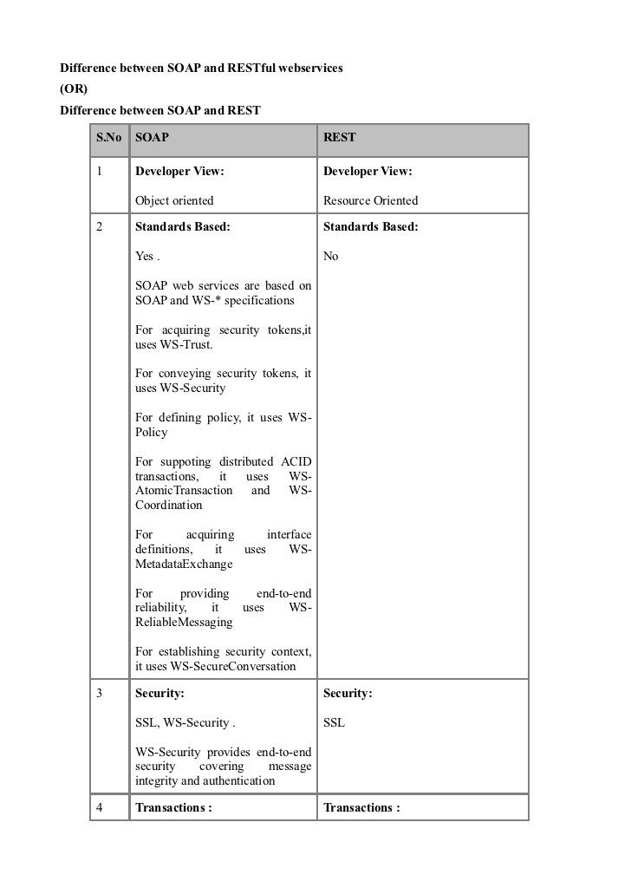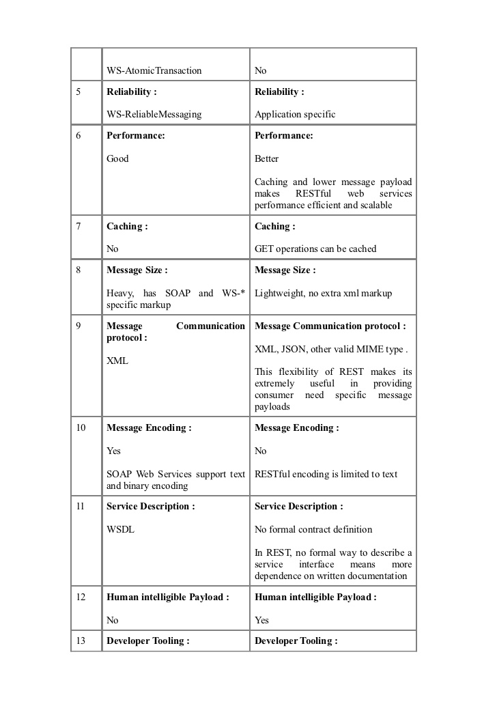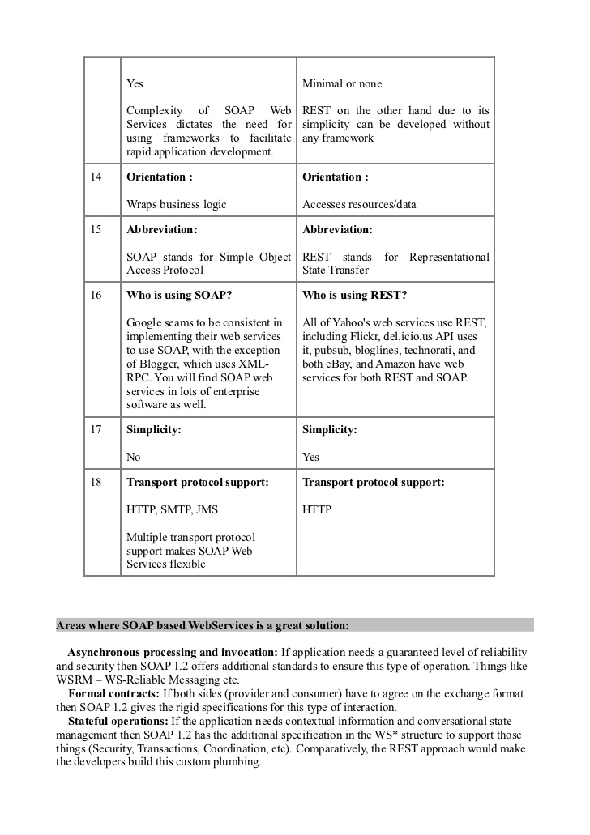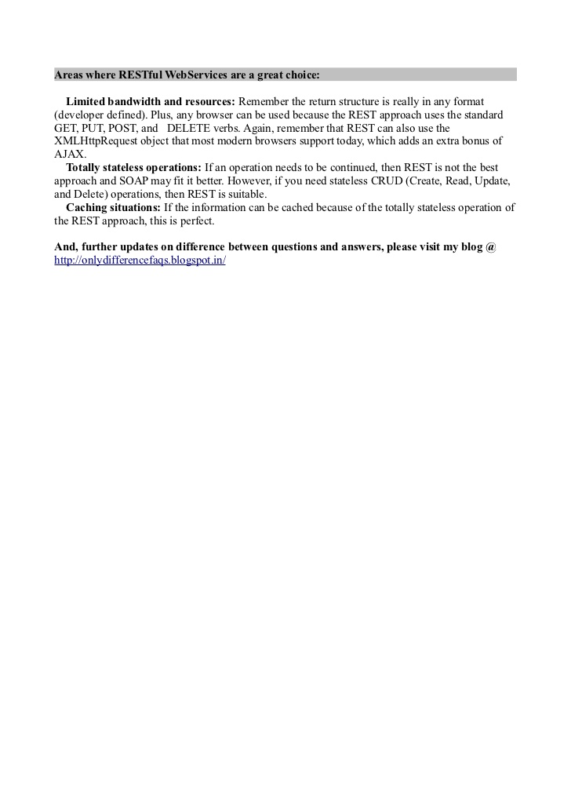

1 of 4

Difference between soap and restful webservices

18,971 views

* Share

* Like

* Download

* ...

[Umar Ali](https://www.slideshare.net/umarali1981?utm_campaign=profiletracking&utm_medium=sssite&utm_source=ssslideview)

[Umar Ali](https://www.slideshare.net/umarali1981?utm_campaign=profiletracking&utm_medium=sssite&utm_source=ssslideview)

, Senior Software Engineer

[Follow](https://www.slideshare.net/signup?login_source=slideview.popup.follow&from=addcontact&from_source=https%3A%2F%2Fwww.slideshare.net%2Fumarali1981%2Fdifference-between-soap-and-restful-webservices)

Published on Aug 18, 2012

This provides difference between SOAP and RESTful Webservices

...

Published in: [Technology](https://www.slideshare.net/featured/category/technology)

* [0 Comments](https://www.slideshare.net/umarali1981/difference-between-soap-and-restful-webservices#comments-panel)
* [9 Likes](https://www.slideshare.net/umarali1981/difference-between-soap-and-restful-webservices#likes-panel)
* [Statistics](https://www.slideshare.net/umarali1981/difference-between-soap-and-restful-webservices#stats-panel)
* [Notes](https://www.slideshare.net/umarali1981/difference-between-soap-and-restful-webservices#notes-panel)

Top of Form

no profile picture user



[Post](https://www.slideshare.net/signup?login_source=slideview.popup.comment&from=comments&from_source=https%3A%2F%2Fwww.slideshare.net%2Fumarali1981%2Fdifference-between-soap-and-restful-webservices)

Bottom of Form

* *Be the first to comment*

 Difference between soap and restful webservices

1. 1. Difference between SOAP and RESTful webservices(OR)Difference between SOAP and REST S.No SOAP REST 1 Developer View: Developer View: Object oriented Resource Oriented 2 Standards Based: Standards Based: Yes . No SOAP web services are based on SOAP and WS-* specifications For acquiring security tokens,it uses WS-Trust. For conveying security tokens, it uses WS-Security For defining policy, it uses WS- Policy For suppoting distributed ACID transactions, it uses WS- AtomicTransaction and WS- Coordination For acquiring interface definitions, it uses WS- MetadataExchange For providing end-to-end reliability, it uses WS- ReliableMessaging For establishing security context, it uses WS-SecureConversation 3 Security: Security: SSL, WS-Security . SSL WS-Security provides end-to-end security covering message integrity and authentication 4 Transactions : Transactions :
2. [2.](https://image.slidesharecdn.com/differencebetweensoapandrestfulwebservices-120818012057-phpapp01/95/difference-between-soap-and-restful-webservices-2-728.jpg?cb=1345252956)WS-AtomicTransaction No5 Reliability : Reliability : WS-ReliableMessaging Application specific6 Performance: Performance: Good Better Caching and lower message payload makes RESTful web services performance efficient and scalable7 Caching : Caching : No GET operations can be cached8 Message Size : Message Size : Heavy, has SOAP and WS-* Lightweight, no extra xml markup specific markup9 Message Communication Message Communication protocol : protocol : XML, JSON, other valid MIME type . XML This flexibility of REST makes its extremely useful in providing consumer need specific message payloads10 Message Encoding : Message Encoding : Yes No SOAP Web Services support text RESTful encoding is limited to text and binary encoding11 Service Description : Service Description : WSDL No formal contract definition In REST, no formal way to describe a service interface means more dependence on written documentation12 Human intelligible Payload : Human intelligible Payload : No Yes13 Developer Tooling : Developer Tooling :
3. [3.](https://image.slidesharecdn.com/differencebetweensoapandrestfulwebservices-120818012057-phpapp01/95/difference-between-soap-and-restful-webservices-3-728.jpg?cb=1345252956)Yes Minimal or none Complexity of SOAP Web REST on the other hand due to its Services dictates the need for simplicity can be developed without using frameworks to facilitate any framework rapid application development. 14 Orientation : Orientation : Wraps business logic Accesses resources/data 15 Abbreviation: Abbreviation: SOAP stands for Simple Object REST stands for Representational Access Protocol State Transfer 16 Who is using SOAP? Who is using REST? Google seams to be consistent in All of Yahoos web services use REST, implementing their web services including Flickr, del.icio.us API uses to use SOAP, with the exception it, pubsub, bloglines, technorati, and of Blogger, which uses XML- both eBay, and Amazon have web RPC. You will find SOAP web services for both REST and SOAP. services in lots of enterprise software as well. 17 Simplicity: Simplicity: No Yes 18 Transport protocol support: Transport protocol support: HTTP, SMTP, JMS HTTP Multiple transport protocol support makes SOAP Web Services flexibleAreas where SOAP based WebServices is a great solution: Asynchronous processing and invocation: If application needs a guaranteed level of reliabilityand security then SOAP 1.2 offers additional standards to ensure this type of operation. Things likeWSRM – WS-Reliable Messaging etc. Formal contracts: If both sides (provider and consumer) have to agree on the exchange formatthen SOAP 1.2 gives the rigid specifications for this type of interaction. Stateful operations: If the application needs contextual information and conversational statemanagement then SOAP 1.2 has the additional specification in the WS* structure to support thosethings (Security, Transactions, Coordination, etc). Comparatively, the REST approach would makethe developers build this custom plumbing.
4. [4.](https://image.slidesharecdn.com/differencebetweensoapandrestfulwebservices-120818012057-phpapp01/95/difference-between-soap-and-restful-webservices-4-728.jpg?cb=1345252956)Areas where RESTful WebServices are a great choice: Limited bandwidth and resources: Remember the return structure is really in any format(developer defined). Plus, any browser can be used because the REST approach uses the standardGET, PUT, POST, and DELETE verbs. Again, remember that REST can also use theXMLHttpRequest object that most modern browsers support today, which adds an extra bonus ofAJAX. Totally stateless operations: If an operation needs to be continued, then REST is not the bestapproach and SOAP may fit it better. However, if you need stateless CRUD (Create, Read, Update,and Delete) operations, then REST is suitable. Caching situations: If the information can be cached because of the totally stateless operation ofthe REST approach, this is perfect.And, further updates on difference between questions and answers, please visit my blog @http://onlydifferencefaqs.blogspot.in/

[Recommended](https://www.slideshare.net/umarali1981/difference-between-soap-and-restful-webservices#related-tab-content)

[[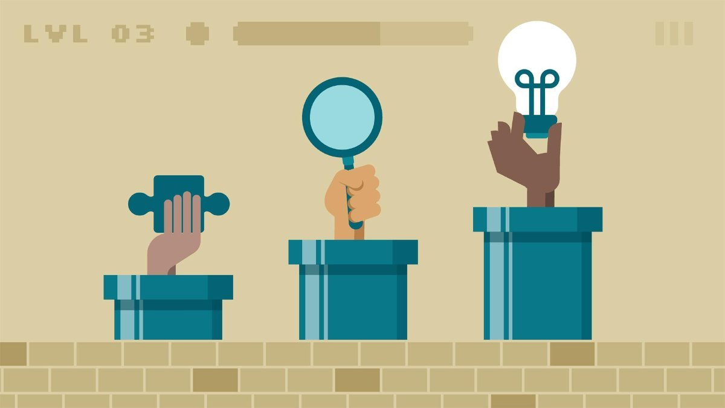](https://www.linkedin.com/learning/gamification-of-learning?trk=slideshare_sv_learning)](https://www.linkedin.com/learning/gamification-of-learning?trk=slideshare_sv_learning" \o "Gamification of Learning)

[Gamification of Learning](https://www.linkedin.com/learning/gamification-of-learning?trk=slideshare_sv_learning" \o "Gamification of Learning)

[Online Course - LinkedIn Learning](https://www.linkedin.com/learning/gamification-of-learning?trk=slideshare_sv_learning" \o "Gamification of Learning)

[[](https://www.linkedin.com/learning/learning-to-write-a-syllabus?trk=slideshare_sv_learning)](https://www.linkedin.com/learning/learning-to-write-a-syllabus?trk=slideshare_sv_learning" \o "Learning to Write a Syllabus)

[Learning to Write a Syllabus](https://www.linkedin.com/learning/learning-to-write-a-syllabus?trk=slideshare_sv_learning" \o "Learning to Write a Syllabus)

[Online Course - LinkedIn Learning](https://www.linkedin.com/learning/learning-to-write-a-syllabus?trk=slideshare_sv_learning" \o "Learning to Write a Syllabus)

[[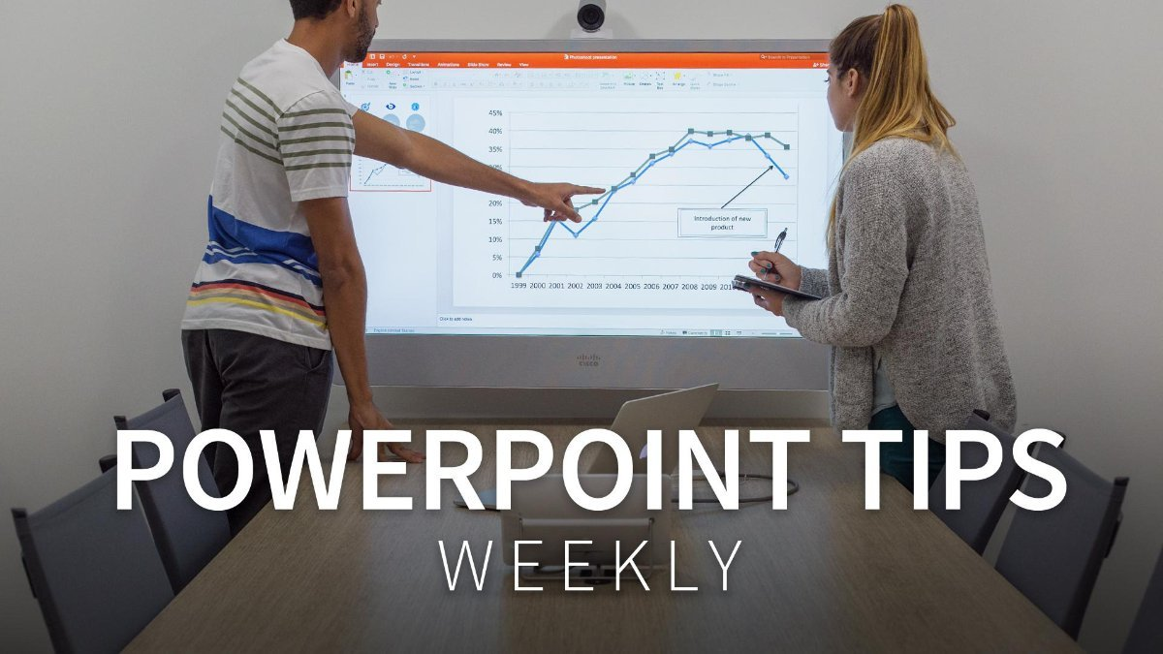](https://www.linkedin.com/learning/powerpoint-tips-weekly?trk=slideshare_sv_learning)](https://www.linkedin.com/learning/powerpoint-tips-weekly?trk=slideshare_sv_learning" \o "PowerPoint Tips Weekly)

[PowerPoint Tips Weekly](https://www.linkedin.com/learning/powerpoint-tips-weekly?trk=slideshare_sv_learning" \o "PowerPoint Tips Weekly)

[Online Course - LinkedIn Learning](https://www.linkedin.com/learning/powerpoint-tips-weekly?trk=slideshare_sv_learning" \o "PowerPoint Tips Weekly)

[[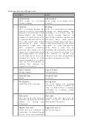](https://www.slideshare.net/umarali1981/difference-between-xml-and-json)](https://www.slideshare.net/umarali1981/difference-between-xml-and-json" \o "Difference between xml and json)

[Difference between xml and json](https://www.slideshare.net/umarali1981/difference-between-xml-and-json" \o "Difference between xml and json)

[Umar Ali](https://www.slideshare.net/umarali1981/difference-between-xml-and-json" \o "Difference between xml and json)

[[](https://www.slideshare.net/sreekveturi/soap-vs-rest)](https://www.slideshare.net/sreekveturi/soap-vs-rest" \o "Soap Vs Rest)

[Soap Vs Rest](https://www.slideshare.net/sreekveturi/soap-vs-rest" \o "Soap Vs Rest)

[sreekveturi](https://www.slideshare.net/sreekveturi/soap-vs-rest" \o "Soap Vs Rest)

[[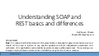](https://www.slideshare.net/BhavendraChavan/understanding-soap-and-rest-basics-and-differences)](https://www.slideshare.net/BhavendraChavan/understanding-soap-and-rest-basics-and-differences" \o "Understanding SOAP and REST basics and differences)

[Understanding SOAP and REST basics and differences](https://www.slideshare.net/BhavendraChavan/understanding-soap-and-rest-basics-and-differences" \o "Understanding SOAP and REST basics and differences)

[Bhavendra Chavan](https://www.slideshare.net/BhavendraChavan/understanding-soap-and-rest-basics-and-differences" \o "Understanding SOAP and REST basics and differences)

[[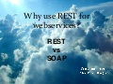](https://www.slideshare.net/alexperezbaron/rest-vs-soap-11863692)](https://www.slideshare.net/alexperezbaron/rest-vs-soap-11863692" \o "Rest vs Soap)

[Rest vs Soap](https://www.slideshare.net/alexperezbaron/rest-vs-soap-11863692" \o "Rest vs Soap)

[Alex Pérez Barón](https://www.slideshare.net/alexperezbaron/rest-vs-soap-11863692" \o "Rest vs Soap)

[[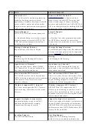](https://www.slideshare.net/umarali1981/difference-between-wcf-and-aspnet-web-api)](https://www.slideshare.net/umarali1981/difference-between-wcf-and-aspnet-web-api" \o "Difference between wcf and asp.net web api)

[Difference between wcf and asp.net web api](https://www.slideshare.net/umarali1981/difference-between-wcf-and-aspnet-web-api" \o "Difference between wcf and asp.net web api)

[Umar Ali](https://www.slideshare.net/umarali1981/difference-between-wcf-and-aspnet-web-api" \o "Difference between wcf and asp.net web api)

[[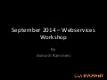](https://www.slideshare.net/clairvoyantllc/webservices-workshop-september-2014)](https://www.slideshare.net/clairvoyantllc/webservices-workshop-september-2014" \o "Webservices Workshop -  september 2014)

[Webservices Workshop - september 2014](https://www.slideshare.net/clairvoyantllc/webservices-workshop-september-2014" \o "Webservices Workshop -  september 2014)

[clairvoyantllc](https://www.slideshare.net/clairvoyantllc/webservices-workshop-september-2014" \o "Webservices Workshop -  september 2014)

[[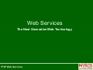](https://www.slideshare.net/nyrostechnologies/webservices-1427617)](https://www.slideshare.net/nyrostechnologies/webservices-1427617" \o "Webservices)

[Webservices](https://www.slideshare.net/nyrostechnologies/webservices-1427617" \o "Webservices)

[Nyros Technologies](https://www.slideshare.net/nyrostechnologies/webservices-1427617" \o "Webservices)

* [English](https://www.slideshare.net/umarali1981/difference-between-soap-and-restful-webservices)
* [Español](https://es.slideshare.net/umarali1981/difference-between-soap-and-restful-webservices)
* [Português](https://pt.slideshare.net/umarali1981/difference-between-soap-and-restful-webservices)
* [Français](https://fr.slideshare.net/umarali1981/difference-between-soap-and-restful-webservices)
* [Deutsch](https://de.slideshare.net/umarali1981/difference-between-soap-and-restful-webservices)
* [About](https://www.slideshare.net/about)

* [Dev & API](https://www.slideshare.net/developers)

* [Blog](http://blog.slideshare.net/)

* [Terms](https://www.slideshare.net/terms)

* [Privacy](https://www.slideshare.net/privacy)

* [Copyright](http://www.linkedin.com/legal/copyright-policy)

* [Support](https://www.linkedin.com/help/slideshare)

LinkedIn Corporation © 2018